Literature Review

Simluating the internet proper is near impossible, due to its shear scale, impracticality and the number of nodes needed (Sumeet Kumar and Kathleen 2017). But it is certainly possible to create software that facilitates the entire load testing process (Yan et al., 2014). It helps developers to understand their application in extreme circumstances (PR Newswire Association LLC, 2014).
Simulation has played a vital role in system verification for a long time; however, it requires a great deal of time and resources. But its usefuleness and importance in software engineering has been noted in great detail by many authors (Sun & Männistö, 2012). Test tools can be considered an addendum to normal development and perform a task related to but seperate to direct development (Na and Huaichang, 2015). Load testing is vital to proving that web services (and other load based systems) meet the demands of its users, both in traffic and behaviour (Draheim et al., 2006), and is as important to the testing of an application as unit testing and integration testing (Jiand & Hassan, 2015). It can help to locate issues in the code that might not appear under smaller load. These errors are called “Load sensitive”. The rate at which transactions are conducted constitutes load. Workload (descrbied by characteristics and intensity), environment and, high-level metrics all define a load test and its results intensity refers to arrival rate and throuput of data (Malik, 2010). Sending this to a target for test purposes, constitutes a Load Test (Jiang, 2015).
Stress testing is similair to workload, however the express intention is to break the system, and to verify how it recovers (Bayan and Cangussu, 2006)(Jiand & Hassan, 2015). All of these come together in a test report (Malik, 2010).
Load testing is performed in some degree on implemented systems as opposed to the design or architecture of the system in question (Jiand & Hassan, 2015). The purpose of a load test is to help guaruntee if a given system's performance is acceptable under peak conditions. This means checking response times and resource usage and helping developers, testers, managers and potential customers decide whether the system's performnce is acceptable or more work needs to be done to bring it to within acceptable limits. While all this happens there are still any other factors to consider (Zhang et al., 2011).
As focus shifts towards offering software as a service with offsite hosting (a.k.a. “The Cloud”), and datacenters, more and more emphasis must be put on testing these systems that require incredible high throughputs due to the sheer numebr of people accessing them and the complex actions that they perform. However, this also extends to making sure that a load tester can be provided/offered as-a-service (aaS) (Shojaee et al., 2015). Even classic server arrangements require load testing to some degree to guaruntee their service is robust and reliable (Cico & Dika, 2014).
Mercury Interactive's LoadRunner was once the load testing leader (Draheim et al., 2006). DITG, Harpoon, fudp, 2Hping, LoadUI, ApacheJmeter, and, curlLoader are currently available open source traffic generators, curlLoader has been noted for its flexibility (Bhatia et al., 2014) (Yan et al., 2014). Testmaker is another WS load tester that allows concurrency testing on Amazon EC2 and joins the open source load testers along with SoapUI and SOATest (The latter being noted for its growing popularity) (Grehan, 2005) (Yan et al., 2014) (Shojaee et al., 2015).
IBM Rational Performance Tester, SURGE and AlertSite (Hasenleithner and Ziegler, 2003) (Yan et al., 2014) are some closed source alternatives with proper support systems in place, AertSite even offers aftercare support to better help businesses understand and solve issues brought up from load testing.
Yet another tool, Iometer, can be used to gauge hardware usage and test performance of storage systems without complicated testbeds (Baltazar, 1998), which provides some direct insight into the hardware side of loadtesting.
Tests often need to be parameterised and modified, this can often be quite hard to do and means more advanced tools are needed (Draheim et al., 2006). Load test analysis methodology has been performed before (Malik, 2010) and it’s been shown that models can even be computer generated based on behaviour observation (Bayan and Cangussu, 2006).
Current tools support simple test cases with a fixed sequence of actions (Draheim et al., 2006) with a limited number of scenarios (Bhatia et al., 2014)

As software shifts towards being offered "as a service" (-aas). Offering some sort of load tester as a service would be wise, and allow for future proofing. A Load tester will likely contain four major components: Test Receiver, Test Manager, Middleware Manager and a Test Runner:
- Test Receiver: Receives tests to run from the tester, can also monitor tests
- Test Manager: Manages queues fo tests and dispatches them, gathering and merging test results
- Test Runner: Invokes the tests. Analyses validity of results
- Middleware Manager: provides and amanges testrunners for use within the system
(Yan et al., 2014)
Giving the user the option of adjusting the size and rate of sending is beneficial. Existing approaches consist of increasing the query size, number of queries or, the rate at which queries are made (Zhang et al, 2011). XML is also already used by large swathes of developers and engineers inluding many protocols themselves(Garg and Lavahte, 2017). JSON is not as widely supported regarding protocols and can fall over when it encounters special characters (however this is purely implementation dependent).
Some solutions do not provide workflow testing or even true load testing. They can also make documentation more difficult (Garg and Lavahte, 2017). Cross-platform running would be a boon to making sure that the most amount of people possible are reached (Garg and Lavahte, 2017).
Other software already offers a great deal of different testing approaches and services for maximum beneficial interaction (Garg and Lavahte, 2017). Allowing for scripting support of any kind would be very beneficial in making sure that the process can be automated with minimal user interaction and to better fit into an AGILE work flow (Shojaee et al., 2015). There are several limitaions to load testing currently: Cost-effectiveness, increasing input size may be very costly and could force the system to continually perform the same computation (Zhang et al., 2011).
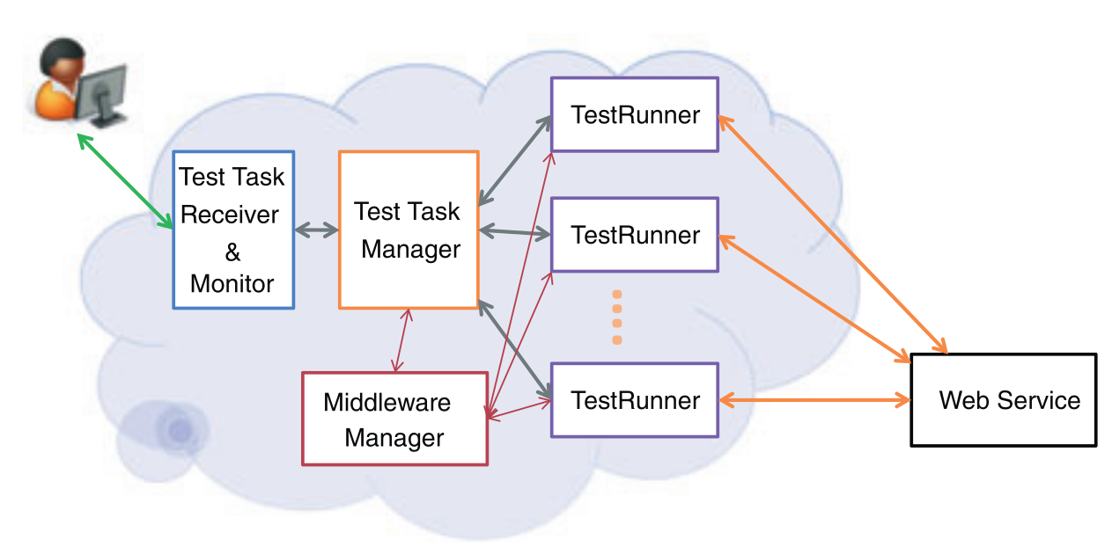Figure 1: Theoretical layout of a web-service (Draheima and Weber, 2005)
Artificial traffic generation is often the only practical way to really verify the running of a service. Hardware traffic generation often leads to greater packet drop at the target but it is faster than a software solution however, it also comes at a greater cost. Also, generating precise traffic allows much greater control (Bhatia et al., 2014).
Load testing should be performed regularly to make sure that resources are correctly provisioned (Draheim et al., 2006). Different Modes need to be offered for proper testing; Static, step and maximal testing are three such modes. Static runs for a specific load. Step runs for measuring usability under a load span. Maximal load to determine upper limits (Yan et al., 2014). Load testing can turn up a variety of problems including: memory leaks, error keywords, deadlocks, unhealthy system states and throughput problems (Jiand & Hassan, 2015).
Testing must be performed even on the smallest servers and services. Without testing significant amounts of resources could be lost to minor bugs cropping up and taking out the entire system when they could have been found during a simple load testing phase during development/setup (Koh et al., 2018). Large scale systems especially so must be tested to make sure that they can still service the millions of simultaneous requests every second (Jiang, 2015). As the demand on servers increase, and as more things become cloud based, it will be become increasingly vital to test these systems to verify they still maintain maximum throughput. Especially as users attempt to store and access files on these services (Baltazar, 1998).
Load testing works best with lots of different entities fully flexing a system (Chapuis & Garbinato, 2017). AGILE development works best with higher amounts of automation and as dterministic results as possible (Garg and Lavahte, 2017). However different runs of the same test may produce different results anyway (non-dterministic) so it would be good to limit these situations as much as possible (Hwang et al., 2004). No matter the system being tested a “client/server” model will be used for all interactions (Hwang et al., 2004).
Manually testing web services would be incredibly labourious, slow and expesnive (Garg and Lavahte, 2017). Real user data can (and should) be used to model traffic. However, such models are less versatile than stochastic ones. Script driven approches are common; visual editors massively increase usability (Draheim et al., 2006).
Reconfigurability for a variety of different connections for different purposes and clients and tests. Low cost, low resource would be a signifcant boon, however using the resources as efficiently as possible is key. Traffic load co-ordination would also help to improve results and efficency with traffic aggregation to make sure all traffic acts on a single interface at the target. Being able to monitor the traffic is also a good feature to have (Bhatia et al, 2014).
Another structure would involve: Input identification, controller tuning and a controller. Input Identification involves finding inputs that affect the resource of interest. Controller tuning involves figuring out the internal parameters of the chosen controller. The controller itself drives the testcases to what load level is wanted. (Bayan and Cangussu, 2006).
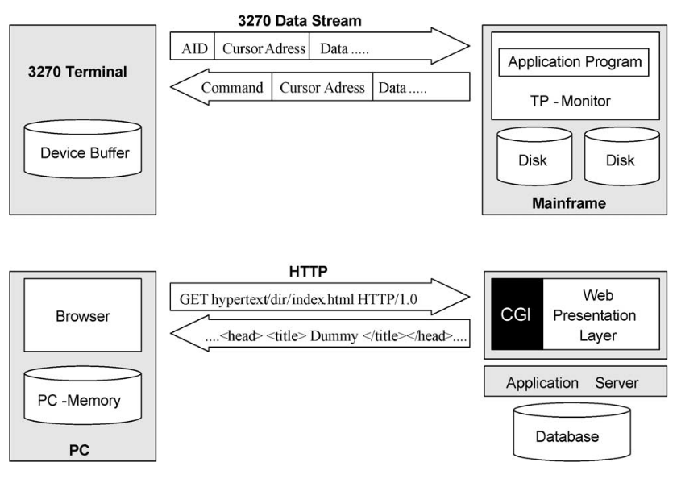Figure 2: Examples of ultra-thin client based submit/response style systems (Draheima and Weber, 2005).
Pseudo random generators are potentially very good for the purposes of this program (Akhshani et al., 2017), while on one hand we need tests to be identical every run to gauruntee that the tests are valid, it can offer some more specialised testing for tests tha tmight run for an entire day, possibly detecting memory leaks and other load sensitive bugs that might only appear under such conditions. The algorithm for constructing a random number generator based on quantum chaotic maps can also be used to create a good chaos model from which to work. Only using user activity graphs instead, to better try to model peak times. (Akhshani et al., 2017) User interaction can be modelled as a bipartite state transition diagram (Draheim et al., 2006).
Geographically distributed instances would improve the results per test task. Large amounts of concurrency within each instance would be good as the loads can be very large, and the taffic could be very high (Yan et al., 2014).
Even though the systems themselves would need testing; load testing from a cloud-based platform would be entirely possible (and preferable in some situations where location of requests is important) (Shojaee et al., 2015). Large amounts of concurrency within each instance would be good as the loads can be very large, and the taffic could be very high (Yan et al., 2014). Being able to scale to simulate potentially millions of requests would be incredibly beneficial to the testing of the software (Jiand & Hassan, 2015).
It is important that the user designs loads well, but more importantly that the software interprets them accurately, this is also a practice left up to the user in creating the plugin (Jiand & Hassan, 2015), however the tests must be interpreted and returned accurately for reading.
Current load testers have a very limited number of virutal users and testing different confgiurations is difficult and time-consuming. Having the ability to scale the software up depending on the users' needs would be highly desireable (Shojaee et al., 2015).
Making sure messages are routed to the correct threads while the system is running is very important as messages can be interleaved by the underlying asynchronous operations (Koh et al., 2018). Making sure that the software can run on a variety of system's will help to maximise its customer base. This can best be acheived by making sure that only the stnadard libraries are adghered to mostly (Baltazar, 1998).
There will be three steps to load testing for the user when it comes to using the software after the plugins ahve been created: designing it, executing it and, analyzing the results (Jiang, 2015). Anomolies should be able to be detected by analysis of the performance metrics and execution logs (Jiand & Hassan, 2015).
Having a variety of ways to check on and use the software would be very useful. This can include a full UI, A task monitor, and a configuration manager. An API for interaction would also be very useful as it would allow different ways of interacting with the system for different purposes. Being able to extend the program beyond its basic function would be an incredibley useful feature and is already in place in many modern systems such as Robot (Na and Huaichang, 2015).
Other great fatures to have that are present in other systems are custom load testing “Scripts”, specific agents, environment switching, test debugging and performance monnitoring. Maximising what tools it can integrate would be a great help to supporting the AGILE workflow too, with integration with systems such as Maven, Hudson, Navigator, Junit, ApacheAnt (Garg and Lavahte, 2017).

